**Project – MySQL Pen Testing**

Members: Darrell Liwanag, Dalton

**Guidelines**

1) Each member must submit a copy with all group members name

## **Tasks**

**Task 1. Nmap scan of the server**

· Take a screenshot of the outcome.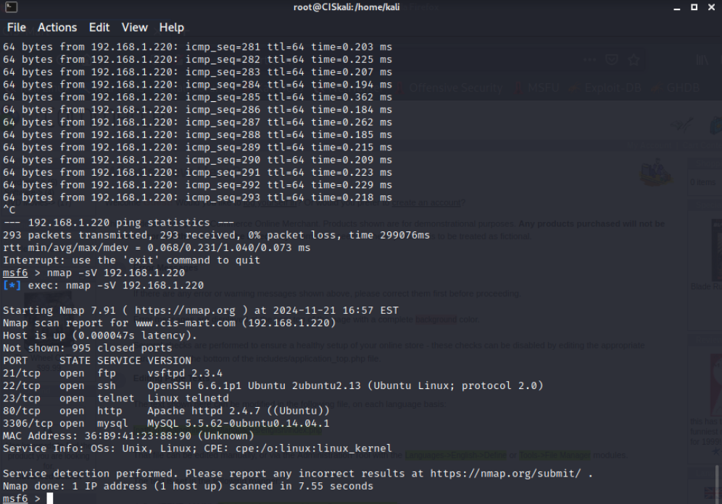

· Describe your observation after a nmap scan.

* The scan provides specific version information for the services, which is critical for identifying potential vulnerabilities. For instance, the MySQL version (5.5.62) is an older release, suggesting it might be susceptible to known exploits.
* The host appears to be well-configured, with only essential services running, while 995 other ports are closed. This indicates some level of security hygiene but also highlights the presence of potentially vulnerable services like FTP, Telnet, and older MySQL versions.
* The HTTP service (Apache) suggests that this server likely serves as a web application, aligning with its role as an e-commerce server.

**Task 2. Brute-forcing logins**

· Take a screenshot of the outcome.

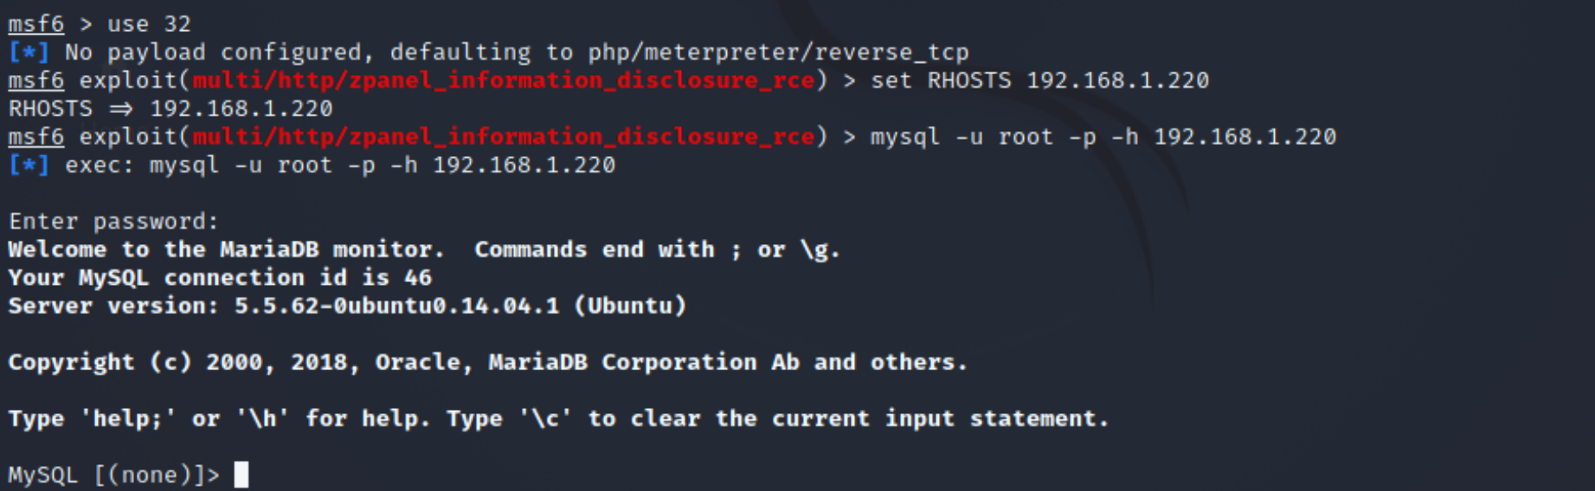

· Explain what you have accomplished.

* In this step, our team used Metasploit to simulate a brute-force attack and successfully connected to the MySQL server on 192.168.1.220 as the root user using the provided credentials (root/root). This confirmed that the server is vulnerable to unauthorized access due to weak or default login credentials. Upon logging in, we verified that the server is running MySQL version 5.5.62-0ubuntu0.14.04.1, an outdated version known to have several vulnerabilities. This connection demonstrates how attackers could gain access to privileged accounts and exploit the database further.
* Our accomplishment highlights the risks associated with weak credentials while laying the foundation for subsequent tasks, such as enumerating database users and dumping password hashes. It also demonstrates our ability to leverage tools like Metasploit to identify and exploit vulnerabilities, emphasizing the importance of implementing robust security measures to protect database servers from unauthorized access.

**Task 3. Obtaining MySQL version**

· Take a screenshot of the outcome.

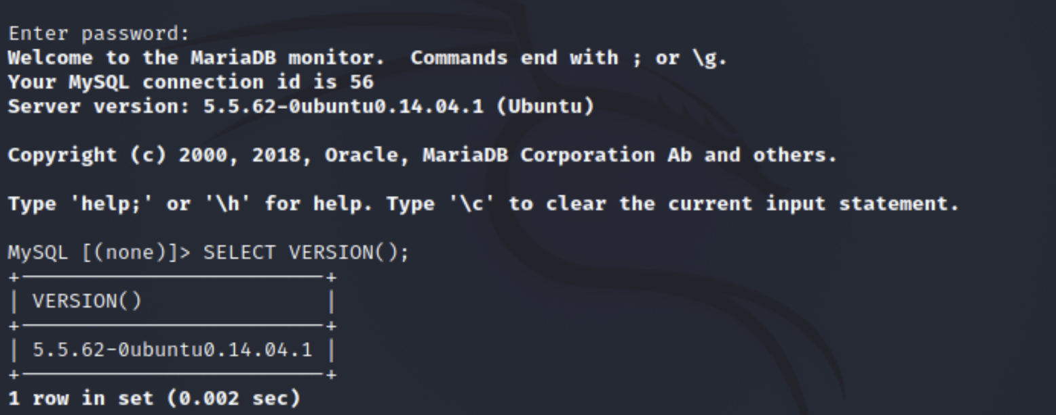

· Describe explicitly the version of MySQL.

* In Task 3, the explicit description of the MySQL version refers to the detailed analysis of the information obtained after executing the SELECT VERSION(); command on the MySQL server. The result shows that the server is running MySQL version 5.5.62-0ubuntu0.14.04.1, which is a part of the MySQL 5.5 series released by Oracle.
* This version, while functional, is outdated and no longer supported in terms of updates or security patches, making it vulnerable to known exploits. It was packaged specifically for Ubuntu 14.04.1, an older Linux distribution that is also no longer supported. The lack of updates means this version is at risk for a variety of potential attacks, such as authentication bypasses, privilege escalations, and SQL injection vulnerabilities. Identifying this version is crucial as it allows us to match known vulnerabilities to this specific release and assess the risks present on the serve

**Task 4. Enumerating MySQL Users**

· Take a screenshot of the outcome.

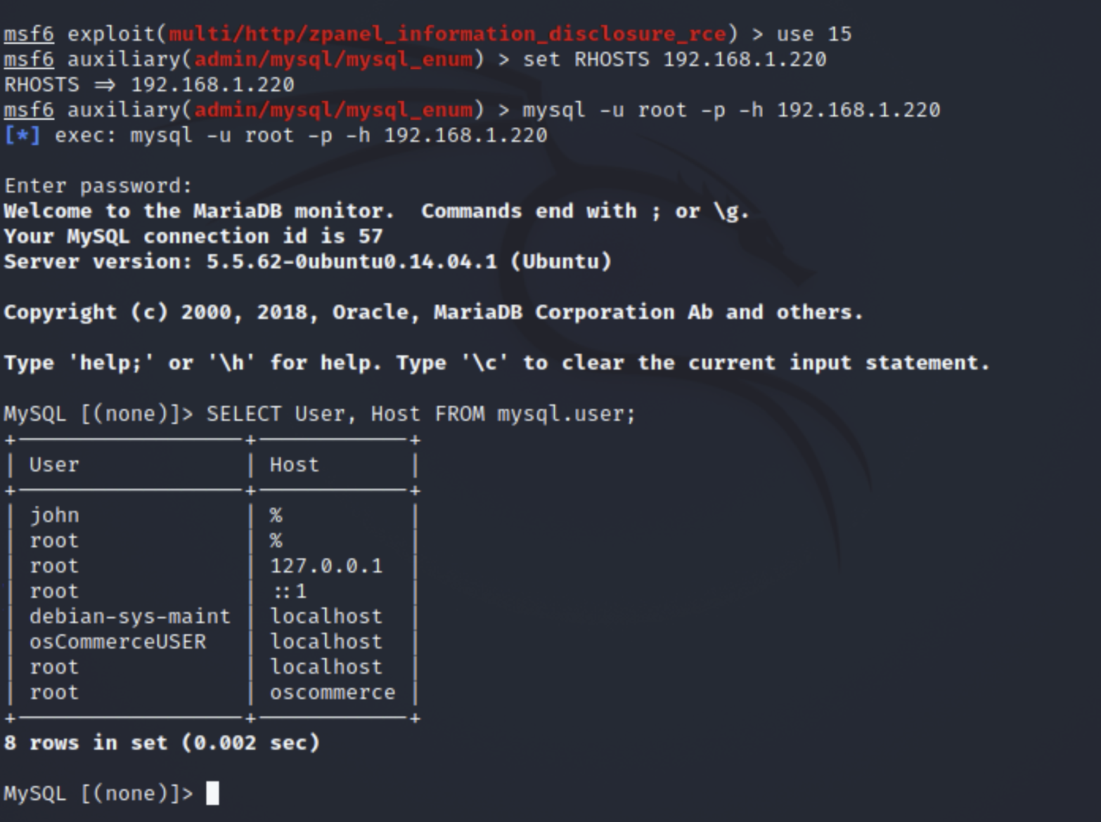

· Describe explicitly MySQL users you’ve extracted.

The team enumerated MySQL users and found several accounts, including john and root, with some configured to allow connections from any IP address (%), posing a security risk. The root user has multiple entries, each tied to specific hosts like localhost, 127.0.0.1, and oscommerce, indicating various connection methods. System and application accounts, such as debian-sys-maint and osCommerceUSER, are also present, with roles likely tied to server maintenance and the e-commerce application. These findings highlight vulnerabilities, such as overly broad access permissions, and emphasize the need for stricter access controls and permission reviews.

**Task 5. Dump password hashes of MySQL Users**

· Take a screenshot of the outcome to report the password hashes you’ve extracted.

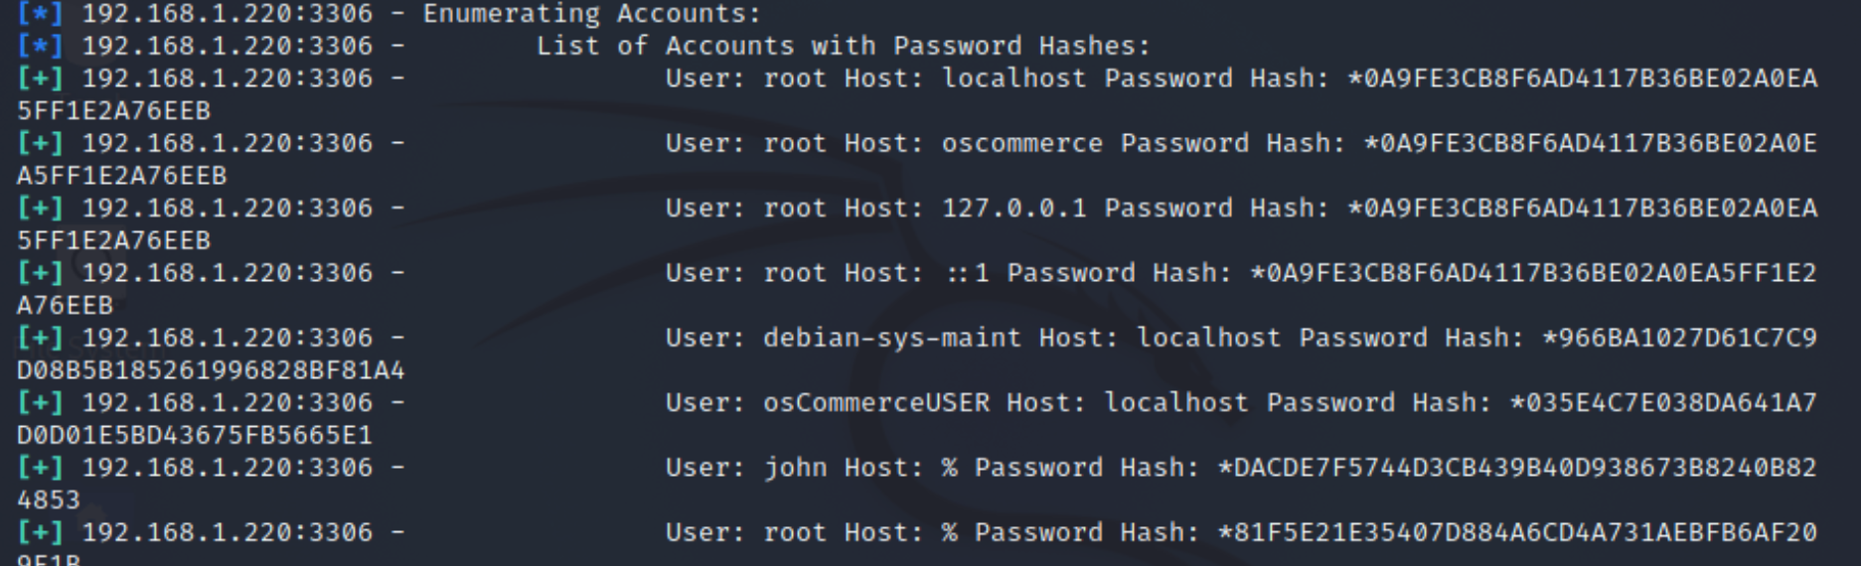

**Task 6. Dump database schema**

· Take a screenshot of the outcome.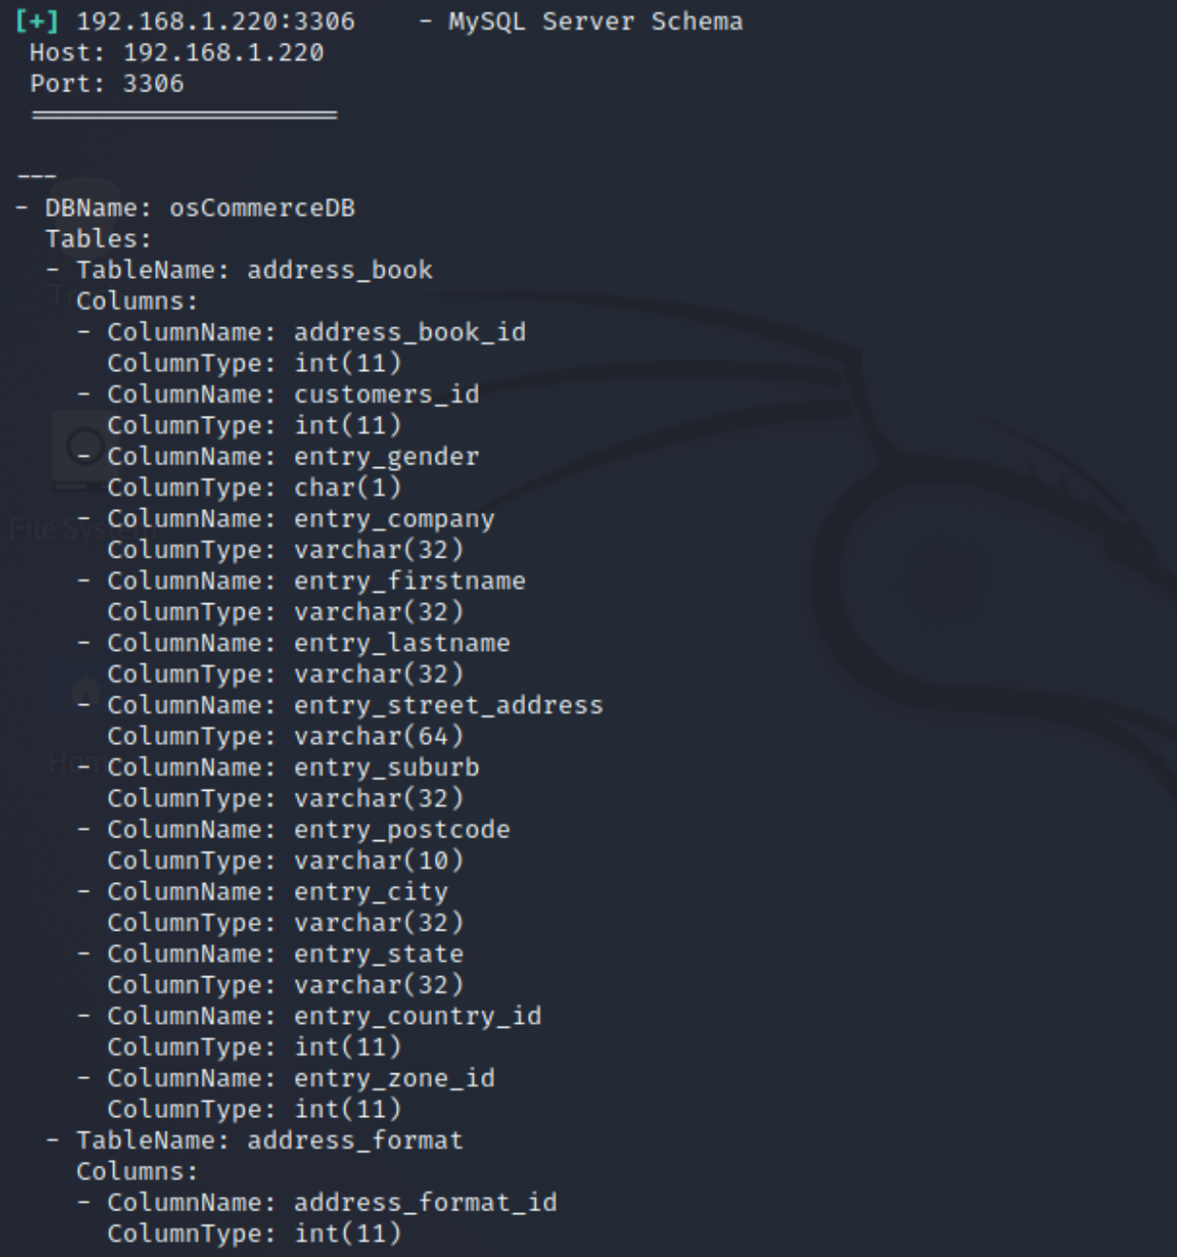

· How many tables did you find?

After reviewing the schema, I found a total of 47 tables in the osCommerce database, which gave me a clear understanding of its structure.

47 tables in the osCommerce database

